BUBBA SHACKELFORD & FALCON TRADING Co.

Falcon Trading Company was started in the early 1980s by Cowboy Bubba Shackelford in Prescott Arizona. Bubba got his earliest start from Jock & Al Favour who are a part of a group of Anglo artists (Jesse Robbins for one & who actually got his start working with Bubba at Falcon), Charlie Favour, Joe Eby, Dennis Hogan, etc.)
Bubba began by selling his jewelry out of his Ford Falcon automobile all over town, giving Falcon Trading Company its namesake. Bubba produced FTC jewelry for many years afterwards, until his sight began to fade from diabetes. In 2014 Bubba took on a young student at that time named Joe O'Neill, who is now the head silversmith at Falcon Trading, and works with Bubba daily to continue on the tradition of creating beautiful tufa cast ingot jewelry in the southwestern/Santa Fe style. Bubba demanded that the jewelry be made right & everything has Bubba's approval!

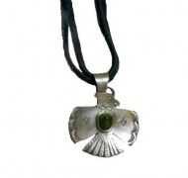 | 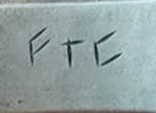

BISCHOFF’S GALLERY 3925 N. Brown Ave. Scottsdale, AZ 85251 (480) 946-6155 www.bischoffsgallery.com

